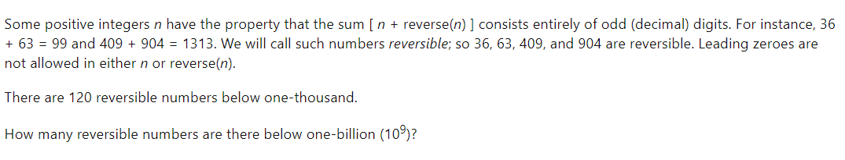

How many 20 digit numbers n (without any leading zero) exist such that no three consecutive digits of n have a sum greater than 9?